**Google’s Colaboratory Setup Instructions**

1. Go to this Google Drive link:

<https://drive.google.com/drive/folders/1tq1IJDUtFKiKWo2JNvvIOo-WaAbk1cCa?usp=sharing>

1. Sign into your Google Drive or set one up.
2. Click on the Day 0 - Python Intro folder name and select Add To My Drive (You’ll only be able to run these files if you have your own copy saved.)

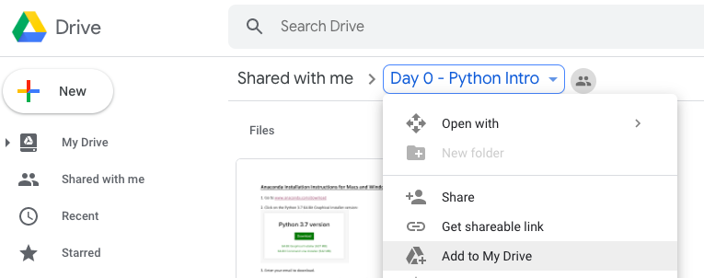

1. Navigate to the Day 0 folder that you just saved in your My Drive.
2. To open the Hello World Intro.ipynb file, you can right click and open with the Colaboratory app. You may need to “Connect More Apps” and search for Colaboratory if you don’t have it yet.

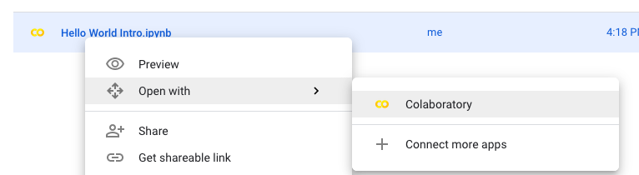

1. If everything goes according to plan, you should now be able to click on the play button to run the first line of code.

